Geometry: Unit 4, Lesson 5

- A sequence of transformations on point $(-8, 3)$ are described.
$$(x, y)→(-y, -x)$$
$$(x, y)→(x+2, y-1)$$
$$(x, y)→(-y, x)$$
What is the $x$-value of the point after this sequence of transformations?

$$-7$$

- An object on a plane is transformed using a sequence of transformations by first having both its $x$ and $y$-coordinates become their opposites, $(x, y)→(-x, -y)$, and then having its $x$-coordinate become its opposite, $(x, y)→(-x, y)$. What is a written description that represents the transformations?

This object was first rotated $180°$ clockwise, and then reflected over the $y$-axis
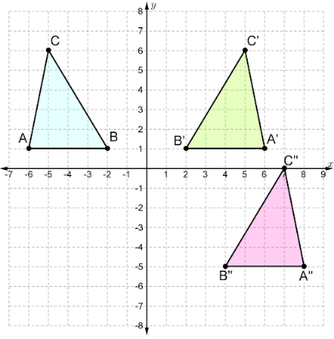
- Triangles $ABC$, $A'B'C'$ and $A''B''C''$ are shown on the coordinate grid. What sequence of algebraic transformations maps triangle $ABC$ onto triangle $A'B'C'$ and then onto triangle $A''B''C''$?

$$ABC→A^{'}B^{'}C^{'}:(x, y)→(-x, y)$$
$$A^{'}B^{'}C^{'}→A^{''}B^{''}C^{''}:(x, y)→(x+2, y-6)$$

